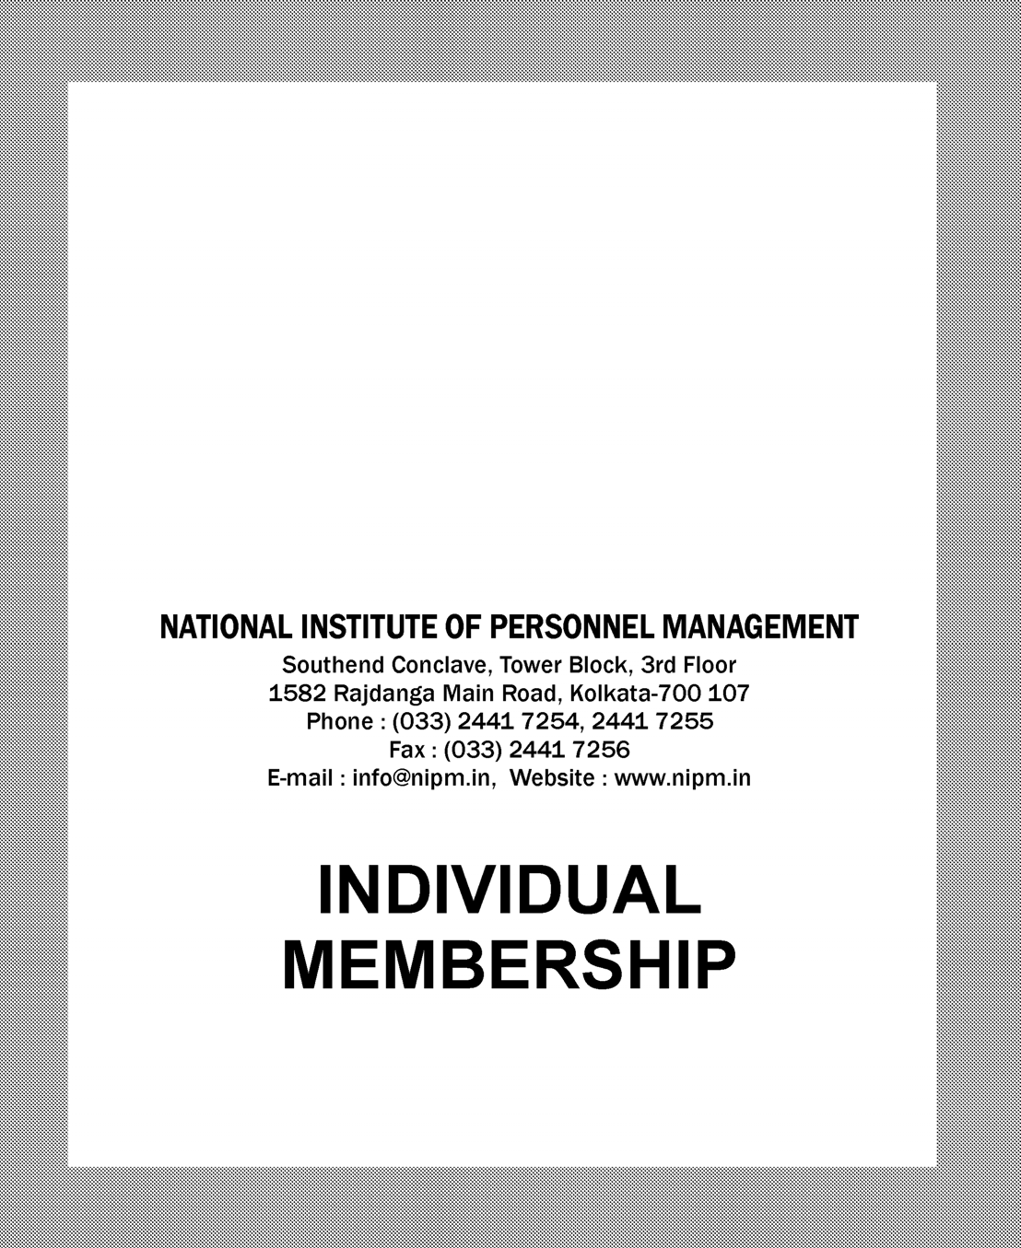

Southend Conclave, Tower Block, 3rd Floor 1582 Rajdanga Main Road, Kolkata-700 107
Phone : (033) 2441 7254, 2441 7255
Fax : (033) 2441 7256
E-mail : info@nipm.in, Website : www.nipm.in

INDIVIDUAL MEMBERSHIP

OBJECTIVES
- To promote excellence in professionalism in the HRM
/ HRD area;
- To provide a forum for exchange of ideas and experiences and collection and dessemination of Information on management in general and personnel management in particular;
- To spread the knowledge on the principles, practices, techniques and methods of human resource management and development and to develop the skill and expertise of the persons engaged in the management and development of human resources;
- To promote and safeguard the status and interests of personnel management, industrial relations and labour welfare and the interests of those engaged therein etc.

MEMBERSHIP-ELIGIBILITY CRITERIA

1.CORPORATE
For admission to corporate membership an individual should possess the qualification as at (a) above and in addition. should (i) has at least three years practical experience in any assignment in personnel management/general management / human resource management or industrial relations or labour welfare, if he / she has a degree or diploma in any other stream and (ii) be holding any managerial or administrative or staff training position in any organisation whether in public or private sector engaged in an industry, trade or commerce and be dealing with personnel management
/ general management / human resource management or industrial relations or labour welfare or any branch or any aspect of them; or be working as adviser / Consultant to any industrial training, commercial or employers’ organisation and be dealing mainly with personnel management or industrial relations or labour welfare in a recognised educational institution.

2
2.LIFE
Any individual who is eligible to become a corporate member or who is already a Corporate member may become a Life member by making payment of Rs. 9,000/-

3.INSTITUTIONAL
The Central or any State Government or any local self Government or any local self Government body or any of their departments or any statutory body or corporation, statutory or otherwise, or any organisation or any Educational institution or any association, whether incorporated or not, which subscribes to and is interested in furtherance of the objects of the institute is eligble for institutional membership.

MEMBERSHIP-ENROLMENT
To apply for membership please fill in the enclosed applicaion form. get it proposed and seconded by Life
/ Corporate members of the Institute and send it along with demand draft / at per cheque for the amount covering entrance fee and Annual Membership Subscription to the Hony. General Secretary of the Institute through the Hony. Secretary of the concerned Chapter, if you reside within the territorial jurisdiction of any Chapter or directly if you reside outside the jurisdiction of any of the Chapters.
After the application has been scrutinised by the NIPM Secretariat, it will be considered by the Membership Committee and approved by the National Council. Thereafter, you will be informed about your admission to membership, indicating the class of membership and date of admission.
New membership are enrolled on the basis of financial year of the Institute.

MEMBERSHIP-RIGHTS AND PRIVILEGES
The membership of NIPM is a recognition of the high standards of your professional attainments and your commitment to the causes and furtherance of professionalism in the management and develompemnt of human resources to which NIPM is devoted it gives you a chance to establish valuable contacts with fellow members, exchange ideas and information, and represent issues of common concern at local and national forums. You are entitled to a wide range of services and development activities directed towards enchancement of your professional skills. You are also entitled, as a member of NIPM to.
- attend and participate in the meetings, discussions, lectures, film shows and such other programmes which are organised by the Institute or its Chapters.

- Participate at concessional rates in the management training and development programmes organised by NIPM or its Regions and Chapters.  - copy of the Institute’s half-yearly journal “Personnel Today” to be given free of charges and Institute’s “NIPM e-Newsletter” to be provided in NIPM Website (www.nipm.in).  - a copy of the journal, newsletter, bulletin or such other publications brought out by the concerned Chapter free of chage.  - the use of Library / Information centre at NIPM National Office and / or at the concerned Chapter.  MEMBERSHIP-DUTIES AND RESPONSIBILITIES  - Every person admitted to any class of membership of NIPM shall be liable to follow in his/her professional practice, as a member in any rank of management, the CODE OF ETHICS of the institute and shall also make a genuine attempt to adhere to the standards laid down in the Code in all his / her dealings.  - Every person admitted to any class of membership of NIPM shall conduct himself / herself in such a manner as to preserve NIPMs image and dignity and shall not misuse authority or office for personal gain and self-interest.  - Every member will be liable to pay the appropriate annual subscription which becomes due and payable before 1st April every year.  - Any member not clearing up his / her annual subscription within three months of the commencement of the year i.e. 30th June, shall be treated as a defaulter. If the defaulters fail to clear up their subscription latest by 30th September, their names are liable to be removed from membership.  - A person removed from the membership of the Institute may be readmitted as a member in the same class to which he / she belonged previously by the Council, on an application made by him / her on that behalf, provided he / she clears up all arrear subscription before he / she can be readmitted by the Council.  - A member shall if so facto cease to be a member of the Institute of his / her death or if he / she withdraws his / her membership or if he / she is adjudicated by a competent Court to be of unsound mind or is convicted for an offence involving moral turpitude. A Student member shall ceases to be such member immediately on cessation of his / her studies for the course for a degree or diploma on the basis of which he / she was admitted to membership.  - The Council may after due investigation, suspend for any period any member form the membership of the | Institute for any act of omission or commission which is in violation of the memorandum and regulations or is against the interest of the institute or constituted neglect or refusal to abide by any Regulations and Bye-Laws of the Institute or the concerned chapter, or is likely to bring discredit to the Institute, provided that no member shall be suspended unless he / she has been given an opportunity to explain his / her conduct. A suspended member shall cease to be entitled to the benefits and right of membership, but he / she shall have a right to appeal against such decision to the General Body of the Institute in a General meeting immediately following such suspension provided he / she files the memorandum of appeal with the Hony. General Secretary within sixty days of his / her suspension.  8. Any member may be expelled by the Institute by the General Body. Provided that such decision is taken by a two-third majority vote of members present and voting at the General Meeting held for the purpose and the member proposed to the expelled has been given an opportunity to explain the charges levelled against him / her.  DELEGATE AT THE GENERAL MEETINGS  - All Life and Corporate Members shall have one vote each at the General Meetings.  MEMBERSHIP-SUBSCRIPTIONS  Class of Entrance Annual Membership Fee Subscription
 | Rs. Rs.
Fellow Nil Nil
Corporate 500/- 1000/-
For Life Membership one has to pay Rs. 9,000/- and Rs. 1,000/- as Entrance fee only.
All Subscriptions and entrance fees will have to be paid by a bank draft in favour of ‘National Institute of Personnel Management’, Kolkata / Cheque (at par) / NEFT or Online through our Website : www.nipm.in. Please add 18% GST on Membership fees for all categories of Membership.

NIPM - A PROFILE
Ahmedabad Allahabad
A. P. (Hyderabad) Asansol
Assam Aurangabad Baroda Bhilai Bilaspur Bokaro Coimbatore
Dehradun
Delhi Dhanbad Durgapur Goa Godavari Haryana Hazira Jaipur
Jamshedur
CHAPTER
Madras Madurai Mahanadi Mangalore Mumbai Mysore Nagpur Nashik Neyveli
North Karnataka
Karnataka (Bangalore) Kerala (Kochi)
Kolkata
Orissa (Rourkela)
Patna Pondicherry
Pune Punjab Raigad
Rajasthan (Udaipur) Ranchi
Salem Tiruchy Trivandrum
U. P. (Kanpur)
Upper Assam (Sivasagar) Utkal (Bhubaneswar) Visakha
NIPM the short form of the National Institute of Personnel Management, is now the only all-India body of professional managers engaged in the profession of personnel management, industrial relations, labour welfare, training and HRD in the country. NIPM came into existence in March 1980 as a result of merge of two professional institutions, namely the Indian Institute of Personnel Management established in 1948 and the National Institute of Labour Management established in 1950. With its National Office at Kolkata, NIPM has a total membership of more than 10,000 spread over 49 Chapters all over the country. NIPM is a non-profit making body devoted to the development of skill and expertise of the persons engaged into the management of human resources through regular lecture meetings, seminars, training courses. conferences and publications through its Chapters throughout the country.
NIPM has been consistently serving the cause of HRM profession in the country for the last four decades and representing the practitioners in industry, both in private and public sectors. governments and academics. As the premier forum in the country. It is constantly striving for excellence in professionalism in the personnel and industrial relations fields through exchange of knowledge and experience of experts from all parts of the worlds.
NIPM having felt the need for such education for personnel managers which would not only take care of the industry’s requirements but also be interdisciplinary in nature, evolved a model curriculum for such education and started its Post- Graduate Diploma Examination in Personnel Management since March 1978, The Post- Graduate Diploma in Personnel Management awarded by NIPM has been recognised by the Government of India for the purpose of recruitment to superior posts. as also by the State Governments of Bihar, Goa, Karnataka, Kerala Orissa, Maharashtra, Andhra Pradesh, Rajasthan. West Bengal as a prescribed qualification for appointment as welfare officers. Apart from the Institute itself several other institutions like Mohandevi Tarneja Memorial Trust, All India Organisation of Employers, Employers’ Federation of India and UP Orissa and Karnataka Chapters of the Institute have Instituted several medals and awards for the candidates of the Diploma Examination.
Passed out candidates, are eligible for pursuing Ph.D in the University of Andhra, Bihar & Kerala

NATIONAL INSTITUTE OF PERSONNEL MANAGEMENT
Southend Conclave, Tower Block, 3rd Floor, 1582 Rajdanga Main Road, Kolkata-700 107 Phone : (033) 2441 7254, 2441 7255, Fax : (033) 2441 7256
E-mail : info @ nipm.in, Website : www.nipm.in

APPLICATION FORM FOR MEMBERSHIP
(LIFE / CORPORATE)
FOR OFFICE USE ONLY |  | Date of receipt of the Application Entrance fee & Subscription Receipt No. Date Amount Membership Committee meeting held on Recommendations of the Membership Committee If membership is not recommended, the reasons therefor  Admitted as a member by the National Council on Membership No.  Chairman/Convenor, Membership Committee Hon. General Secretary
PERSONAL DATA | 1.  2.  3.  4.  5.  6. | Name in full : Mr../Mrs./Miss (in block letters)  Mailing Address(*)  PIN  Permanent Address  PIN  Date of Birth (Date) (Month) (Year)  Telephone No.:(Office) (Resi.) Fax No.:(Office) Mobile No. : E-Mail :
 | NOTE | *Advice about any change in the mailing address in future should be communicated to the institute immediately

 | I |  | Starting from graduation only :
ACADEMIC QUALIFICATIONS | General Education (copy of certificate required) |  | Degree obtained |  | University |  | Year of obtaining the degree
 |  | NOTE | If not a graduate, the last examination passed may be indicated here
 | II | *In Personnel Management, Industrial Relation, Labour Welfare and/or other allied subjects only :
 | Profesional Education  (copy of certificate required) | Degree or Diploma |  | University or Institution |  | Year of obtaining the Degree of Diploma |  | Principal Subjects taken
 |  | N.B. | *Certificates on Completion of prescribed course of study from Central/State Government Labour Department may also be included here
 | A | I | For Employed Persons only :
EXPERIENCE / EMPLOYMENT RECORDS |  | 1.  2.  3.  4.  5.  6.  7.  8. | Present Designation Since (Specify exact date) Name and address of the present organisation  Nature of Business** No. of persons employed in the establishment*** To whom reporting Nature of duties and responsibilities (in reasonable details)  Are you holding a managerial or administrative position? Yes No (Please tick correct box)  Information given in (6) above must be certified by the reporting authority
 |  | NOTE | ** Nature of employer’s business may be described in board terms, such as Manufacturing, Mining, Plantation, Service Organisation, Employer’s Organisation etc.  *** The figure should strictly relate to the establishment in which the applicant has been working in case he/she is concerned with more than one unit, the total number of persons employed in such units may be given.

 |  | II | For Consultants / Advisors etc. in Personnel Management, Industrial Relations or Labour Welfare :
EXPERIENCE / EMPLOYMENT RECORDS (Continued) | Positions held at Present | 1. | Name of the organisation
 |  | 2. | Since when engaged in consultancy or advisory work (Specify exact date)
 |  | 3. | Nature of Services (in reasonable details)
 |  |  | (Please attach separate sheet)
 |  | III | For Teachers /Researchers in Personnel Management, Industrial Relations or Labour Welfare :
 |  | 1. | Designation Since (Specify exact date)
 |  | 2. | Name and address of Institution
 |  | 3. | Nature of Work and/or responsibilities (in reasonable details)
 |  | 4. | Subject of specialisation
 | B |  | Particulars : | 1 | 2 | 3
 | Positions held at Past | 1. | Designation
 |  | 2. | Duration (Specify dates) | From | From | From
 |  |  |  | To | To | To
 |  | 3. | Name & address
 |  |  | of the organisation
 |  | 4. | Nature of Business*
 |  | 5. | No. of persons employed
 |  |  | in the establishment**
 |  | 6. | To whom used to report
 |  | 7. | Nature of duties & responsibilities
 |  |  | (in reasonable details)
 |  | 8. | Were you holding a
 |  |  | managerial or administra- tive position? | Yes No | Yes No | Yes No
 |  | NOTE | ** Nature of employer’s business may be described in board terms, such as Manufacturing, Mining, Plantation, Service Organisation, Employer’s Organisation etc.  *** The figure should strictly relate to the establishment in which the applicant has been working. In case he/she is concerned with more than one unit. The total number of persons employed in such units may be given.

 | NOMINATION |  |  | DECLARATION |  | ADD. INFORMATION
N.B. | Signature Name in full Address  Category of Membership*  Membership No.  Chapter  Remarks of the Chapter, if any | Proposed by Seconded by | This applicarion form for membership of the Institute is from :  Mr./Mrs./Miss | NOTE | By the Applicant | NIPM MEMBERSHIP
*Both Proposer and Seconder must be CORPORATE / LIFE members |  |  |  | Demand Draft or Cheque should be drawn in favour of : NATIONAL INSTITUTE OF PERSONNEL MANAGEMENT. | I certify that the statements made above are true. If admitted, I shall accept the decision of the National Council of the Institute regarding the category of membership and shall abide by the Regulations of the Institute and the Rules framed thereunder from time to time as also the Code of Ethics of the Institute. The entrance fee Rs.1000/- for Life Membership, Rs.500/- for Corporate Membership. One time fee of Rs.9,000/- for Life, Annual Subscription of Rs.1000/- for Corporate Membership are remitted herewith by Demand Draft / Cheque No. Dated  ........................ Drawn on .....................................................................................................................  Date Signature of the Applicant | Were you a Member earlier Yes No  If yes please mention the category of membership and Membership No.

